OOPS LAB TASK
Hania Imran
25k-0523
Task 1:
#include<iostream>
using namespace std;
int main()
{int m,n,p=0;
cout<<"Enter the size of first element:";
cin>>m;
cout<<"Enter the size of second element:";
cin>>n;
int a[m],b[n];
cout<<"Enter first array element:"<<endl;
for(int i=0;i<m;i++)
{cout<<"Enter "<<i+1<<" element:";
cin>>a[i];
}
cout<<"Enter second array element:"<<endl;
for(int i=0;i<n;i++)
{
cout<<"Enter "<<i+1<<" element:";
cin>>b[i];
}
int c[100];
for(int i=0;i<m;i++){
for(int j=0;j<n;j++)
{if(a[i]==b[j])
{c[p++]=a[i];
b[j]=-1;
break;
}
}}
for(int i=0;i<p-1;i++){

for(int j=0;j<p-i-1;j++)
{if(c[j]>c[j+1])
{
int temp=c[j];
c[j]=c[j+1];
c[j+1]=temp;
}}}
for(int i=0;i<p;i++)
{cout<<c[i]<<" ";
}
}
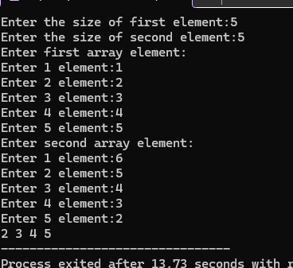
Task 2:
#include<iostream>
using namespace std;
struct employee
{int id;
char name[20];
int salary;
};
int main()
{employee e[3];
for(int i=0;i<3;i++)
{cout<<"Enter the ID of "<<i+1<<" employee: ";
cin>>e[i].id;
cout<<"Enter the name of "<<i+1<<" employee: ";
cin>>e[i].name;
cout<<"Enter the salary of "<<i+1<<" employee: ";
cin>>e[i].salary;
}
int max=e[0].salary;
for(int i=1;i<3;i++)
{if(e[i].salary>max)
max=e[i].salary;
}
for(int i=0;i<3;i++)

{cout<<"\nID of "<<i+1<<"Employee"<<e[i].id<<endl;
cout<<"Name of "<<i+1<<"Employee"<<e[i].name<<endl;
cout<<"Salary of "<<i+1<<"Employee"<<e[i].salary<<endl;

}
cout<<"\nMaximum Salary:"<<max;
}

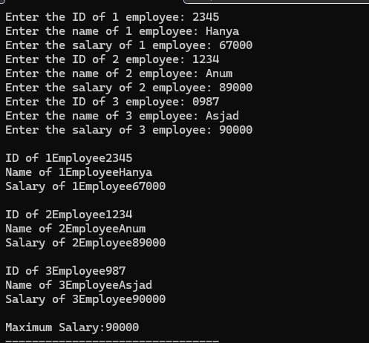
Task 3:
#include<iostream>
using namespace std;
int main()
{int m,n,p=1;
cout<<"Enter the size of first element:";
cin>>m;
cout<<"Enter the size of second element:";
cin>>n;
int a[m],b[n];
cout<<"Enter first array element:"<<endl;
for(int i=0;i<m;i++)
{cout<<"Enter "<<i+1<<" element:";
cin>>a[i];
}
cout<<"Enter second array element:"<<endl;
for(int i=0;i<n;i++)
{
cout<<"Enter "<<i+1<<" element:";
cin>>b[i];
}
for(int i=0;i<n;i++)
{int f=0;
for(int j=0;j<m;j++)
{if(a[j]==b[i])
{f=1;
break;}
}

if(!f)
{p=0;
break;
}

}
if(p)
cout<<"\nTrue";
else
cout<<"\nfalse";
}
}